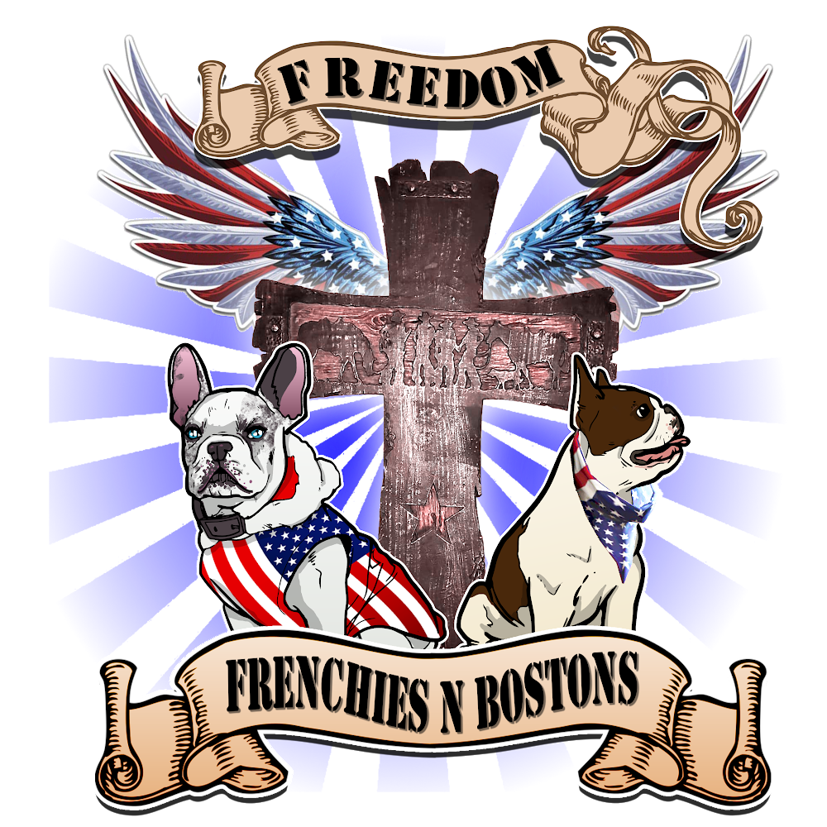
Meredith Hayes
207 Smith St Pocola, Oklahoma 74902
254-913-6441

Guardian Home Contract

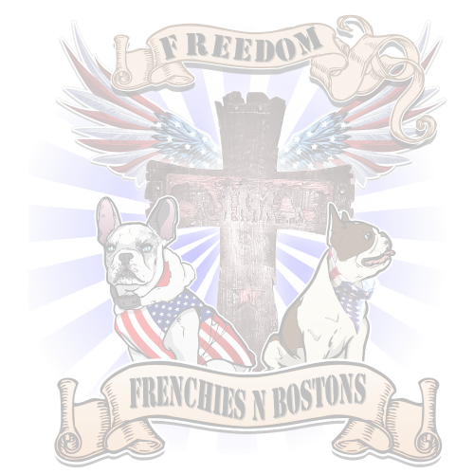
Below are the terms of the Guardian Home Contract agreed upon by Freedom Frenchies N Bostons (Owner) and the below listed guardian. This Guardian Home Contract will outline the terms of the Guardian Home expectations of both the Owner and the Guardian the below listed dog/puppy. This agreement is non-transferrable to any other person(s), Guardian(s), or other dogs/puppies offered for sale or guardianship.

Guardian:

Name

Address

Phone Email

Dog/Puppy Information:

Sire Dam

DOB Call Name/Description

Value Price

MALE FEMALE

GENERAL TERMS: GUARDIAN INITIALS OWNER INITIALS

- Guardian agrees to take physical possession of the above described dog/puppy under the following warranties and conditions. NO OTHER WARRANTIES OR CONDITIONS ARE NEITHER EXPRESSED NOR IMPLIED.

- Both parties (Owner and Guardian), without any emotional or mental reservations whatsoever, are freely entering into this contract.

- Contract/warranties are only implied between the Owner and the original Guardian listed above, NOT to a third party and are not transferable. If at any time the Owner determines the Guardian home is no longer suitable, safe, and/or is detrimental to the dog/puppy, the Guardian will return the dog/puppy to the Owner

within 24 hours and this contract will be terminated immediately with no monetary exchange or financial reimbursement to the Guardian. The Guardian may at any time return the dog/puppy to the Owner and this contract will be terminated immediately with no monetary exchange or financial reimbursement to the Guardian. Any expenses related to the return of the dog/puppy to the Owner are the responsibility of the Guardian.

REGISTRATION: GUARDIAN INITIALS OWNER INITIALS

- The above described dog/puppy will be registered with the American Kennel Club (AKC) by the Owner. The ownership of the dog will be transferred to the guardian once the dog has had four (4) or five (5) litters, at the sole discretion of the breeder/owner and without compensation.

  - The above described dog/puppy is NOT to be registered with any other registry by the Guardian.

- Regardless of Limited or Full Rights, this dog/puppy will not be registered as another breed with any other registry. In addition, dog/puppy cannot be used in the creation of a "new" or "rare" breed in any way, shape, or form nor be bred to any other breed other than a confirmed by three (3) generation pedigree or DNA AKC registered Boston Terrier without written permission from the Owner.

NUTRITION/VACCINATIONS/VETERINARY CARE:

GUARDIAN INITIALS OWNER INITIALS

- The Guardian accepts physical possession of the above described dog/puppy as healthy at the time of pick-up from the Owner. Guardian agrees to provide veterinary care when needed, required, or suggested by a licensed veterinarian. This includes routine care and costs associated with vaccinations, testing and treatment of parasites, and well as monthly flea/tick/heartworm preventative. The Guardian will provide emergency veterinary care in the event of an accident or injury, for the listed dog/puppy for the duration the dog/puppy is in the physical possession of the Guardian. Guardian will provide the original (NO COPIES) of any veterinary care, emergency or routine, including veterinarian name and license number, address, phone number within 24 hours of visit.

  - While in the physical care and custody of the Guardian: If the dog/puppy is found to be ill, injured, or in need of routine veterinary care, the Guardian will immediately notify the Owner prior to treatment. In the event of a life threatening injury and/or emergency, Guardian will notify the Owner while enroute to a veterinarian, regular or emergency clinic/location. Owner reserves the right to have the dog/puppy
re-examined by a licensed veterinarian of the Owner's choice before any further action will be taken or considered. The financial cost of all routine and emergency veterinary care, due to accident or injury is the responsibility of the Guardian.

  - All veterinary care related to the breeding of the above listed dog/puppy is the financial responsibility of the Owner. Breeding related veterinary care includes Genetic Testing, STDs Testing,

OFA,Hips, Elbows, Spine, Heart, Patellas, Dentition, CERF eyes, Progesterone Testing, Insemination, Ultrasound, C-Section, After Birth Routine Care while in possession of the Owner.

- Guardian agrees to feed the dog Pawtree or whatever food the owner is using as to not upset the dog when changing homes through the breeding process. Guardian also agrees to be extremely careful of XYLITOL and sugar substitutes in food/candy/gum as these cause a blood sugar drop and within hours can cause death. This will fall under neglect. Owner has agreed to provide nutritional education and guidance regarding a balanced diet should the Guardian require assistance as well as provide a list of approved supplements and food additives.

- Guardian agrees by signing this contract they give the Owner full permission and authorization to speak to, request documents, disclose, and release, without restriction, all of the dog/puppy’s health information and medical records regarding any past, present, or future medical condition from any licensed veterinarian or technician providing treatment or examination of the dog/puppy.

- Guardian agrees by signing this contract not to permit the dog/puppy to interact with strange animals not in its own household or to visit public places until the dog/puppy is at least four (4) months old AND has obtained all required vaccinations and immunity to avoid the risk of diseases to include but not limited to Parvo-virus, Kennel Cough, Distemper, and other communicable diseases, parasites, or illnesses.

- Guardian will notify the Owner immediately of the listed dog/puppy showing signs (swelling, picky eating, fever, vomiting, etc) of an upcoming heat cycle. The Guardian will notify the Owner of the first day of the heat cycle where blood and/or discharge are present. Guardian understands the importance of this notification to the Owner as well as the importance of protecting the dog/puppy from an unwanted and unplanned pregnancy. Guardian will not for any reason leave the dog/puppy unattended and/or with an intact male dog during a heat cycle. Regardless of circumstances, should the above listed dog/puppy become pregnant with an unplanned pregnancy while in the care and custody of the Guardian, the Guardian will:

  - Notify the Owner IMMEDIATELY of the tie for further decision to be made, possibility of pregnancy, and/or confirmed pregnancy, and

  - Pay to the Owner the full purchase price ($2750) of the dog/puppy, and

  - Immediately schedule the dog/puppy for an emergency spay to abort/prevent the unwanted litter. Upon proof of spay of the dog/puppy, the Owner will transfer the AKC registration papers to the Guardian. The Guardian will keep the dog/puppy, return the dog/puppy to the Owner, or rehome the dog/puppy to a person approved by the Owner and provide the name, address, phone number of the new person to the Owner. If the Owner determines the Guardian home is unsafe and/or unsuitable, the dog/puppy will be returned to the Owner rather than kept or rehomed.

All financial costs associated with an unwanted pregnancy, emergency spay, return of the dog/puppy to the Owner, or rehoming to a new approved person is the responsibility of the Guardian.

TEMPERAMENT: GUARDIAN INITIALS OWNER INITIALS

- Owner cannot guarantee the temperament of any dog/puppy raised outside of the Owner’s immediate care and control. Owner provides the dog/puppy to be of good temperament at the time of physical transfer to the Guardian. Environmental conditions can dramatically impact the temperament; therefore the Owner will not warranty the temperament of a dog/puppy once it has been physically transferred to the Guardian.

- Guardian agrees to make all healthy attempts to properly train and social the dog/puppy to prevent any temperament issues that could arise from poor socialization, isolation, neglect, or actions otherwise not listed.

- Guardian understands the breed and nature of the Boston Terrier having done sufficient research as to the compatibility of this breed to the Guardian’s home, family, and activity level. Guardian understands the stubbornness of the Boston Terrier in training and potty training. Guardian agrees to immediately contact the Owner should any behavioral or temperament issues form in the dog/puppy. Guardian agrees to maintain patience with the dog/puppy and never to strike, hit, kick, or withhold love, attention, or food as a training or punishment method.

LIVING ARRANGEMENTS/WELFARE:

GUARDIAN INITIALS OWNER INITIALS

- Owner reserves the right to inspect any prospective home prior to and after the sale or placement in a guardian home of any dog/puppy. The Guardian agrees to permit the Owner access to the home of the dog/puppy.

- Guardian shall at all times provide a fenced yard/kennel/area or keep the dog/puppy on a leash to ensure safety. Guardian agrees the dog/puppy will never be left outside unattended nor will it be tied or chained outside for any given time or reason.

- Guardian agrees the dog/puppy is first and foremost a companion animal and will live inside the house as a companion. Guardian will not isolate, crate, or lock the dog/puppy in any space for an extended amount of time without human contact and interaction as this type of isolation is detrimental to the physical and mental health and temperament of the dog/puppy.

- Guardian agrees to provide adequate shelter and potable water at all times.

- Guardian agrees to be merciful in discipline and consistent in training. Bark collars will not be used ever. Guardian agrees to socialize and provide exercise in adequate amounts appropriate to the health and age of the dog/puppy in a manner to ensure the health and safety of the dog/puppy first.

HEALTH AND BREEDING: GUARDIAN INITIALS OWNER INITIALS

- The Owner will make arrangements for the OFA testing of the dog/puppy. The Owner will determine the suitability of the dog/puppy’s breed worthiness based on these OFA results (BAER, CERF, spine, heart, patellas), conformation and disposition as it grows. If the Owner determines the dog/puppy is not suitable for breeding:

  - The Guardian may choose to keep the dog/puppy as a pet and will immediately schedule the dog/puppy for routine spay. Any expenses related to the spay of the dog/puppy are the responsibility of the Guardian. The Owner will transfer registration to the Guardian upon proof of spay from a licensed veterinarian. The dog/puppy will remain in the physical custody of the Guardian and not rehomed to a third party. Guardian will abide by the other terms listed in this contract for the duration of the dog/puppy’s lifetime.
  - The Guardian may choose to return the dog/puppy to the Owner within 24 hours of the decision that the dog/puppy is not suitable for breeding. The Guardian will receive no financial reimbursement. Any expenses related to the return of the dog/puppy to the Owner are the responsibility of the Guardian. Upon return of the dog/puppy, this contract will be terminated.

If the Owner determines the dog/puppy is suitable for breeding:

- The Guardian will transport the dog/puppy halfway to the Owner on or before the fourth (4th) day of the heat cycle. The Owner will assume physical custody of the dog/puppy at this time. The Owner will assume any financial responsibility for the dog/puppy during this time until physical custody is returned to the Guardian. The Owner will return physical care and custody of the dog/puppy after the appropriate testing and artificial insemination of the dog/puppy is completed.
- The Guardian will assume financial responsibility of the dog/puppy once physical care and custody is returned to the Guardian. The Guardian will maintain the appropriate and Owner recommended diet, exercise, and routine of the dog/puppy. The Guardian will immediately notify the Owner of any discharge, elevated temperature, change in behavior, or otherwise for the dog/puppy. On or about day 35 from ovulation/insemination, the Guardian will transport the dog/puppy halfway to the Owner for a pregnancy confirmation ultrasound. Both Owner and Guardian will be present for the ultrasound.
- Guardian will transport the dog/puppy halfway to the Owner on or before day 55 gestation. The Owner will assume physical care and custody of the dog/puppy until the puppies are 7 weeks of age. Should the puppies be weaned early, the Owner will notify the Guardian and the dog/puppy can be picked up by the Guardian prior to the puppies being 7 weeks of age.

- After the completion of one successful breeding and litter, the Owner will make the determination whether or not the dog/puppy can, will, and should be bred again or spayed.
  - If the Owner determines the dog/puppy should not be bred again (due to health and/or quality), the Guardian will:
    - Choose to keep the dog/puppy as a pet and immediately spay, then provide proof to the Owner, who will transfer ownership of the dog/puppy to the Guardian. The Guardian may not sell or rehome the dog/puppy to a third party and will adhere to the other terms of this contract.

    - Return the dog immediately to the Owner, thus terminating this contract
  - If the Owner determines the dog/puppy should or could be bred again, the Guardian and the Owner will:
    - Agree to a subsequent litter to be handled exactly as outlined above for the first litter, OR
    - Request a new contract be created to outline the parameters of a subsequent litter, OR
    - Terminate the Owner Guardian relationship where the Owner will transfer registration to the Guardian and the Guardian will assume all risk, financial obligation, and any expenses relating to breeding the dog/puppy on their own.

RESERVATION OF RIGHTS: GUARDIAN INITIALS OWNER INITIALS

- Owner reserves the right to enforce this contract in order to protect the welfare of the dog/puppy.

- The Guardian expressly grants permission for the Owner or their designee(s) to visit the Guardian’s home at any time to verify the welfare of the dog.

- The Guardian further expressly agrees the Owner may repossess the dog/puppy upon any evidence of neglect and/or abuse or upon any breach of this agreement, at no expense to the Owner and with no refund of any monies to the Guardian.

- If the Owner asks for the dog/puppy to be returned to the Owner, due to neglect and/or abuse the dog/puppy shall be returned within 24 hours.

- Should the Owner need to seek legal action against the Guardian for violations of this agreement, the Guardian hereby agrees that he/she/they will assume any and all attorney costs, court fees, and other legal fees incurred in the process of enforcing this contract or of repossessing the dog/puppy.

- Any placement costs, maintenance costs, boarding, medical and associated miscellaneous costs, (such as but not limited to retraining, socialization etc.) related to the repossession of this dog/puppy will be the responsibility of the Guardian.

FIRST RIGHT OF REFUSAL: GUARDIAN INITIALS OWNER INITIALS

If at any time, and for any reason, the Guardian finds they are unable or unwilling to continue to care for the dog/puppy, the Guardian agrees to contact the Owner FIRST prior to selling or giving the dog/puppy away. Under no circumstances should the Guardian take the dog/puppy to a shelter or a rescue for surrender.
The Guardian is required to inform the Owner of such an issue as soon as possible.

- The Owner always gets first right of refusal upon a decision made by Guardian to re-home the dog/puppy sold to them by the Owner.

- If the Owner is for whatever reason unable to take the dog/puppy back, the Owner must approve in writing the new home for any dog/puppy sold by the Owner. Such permission shall not be withheld unreasonably; however, Owner has the exclusive right to determine the suitability of any potential subsequent owner.

- Guardian agrees to either transport the dog/puppy halfway to meet the Owner, or to pay 50% of the shipping/transportation fees to the Owner's location.

- Guardian agrees at the time of transfer of the dog/puppy back to the Owner that all registration papers and medical records be turned over to the Owner, and all necessary paperwork will be signed transferring ownership back to the Owner.

- If the dog/puppy has a permanent form of identification, such as a Microchip or Tattoo, the Guardian agrees to contact the agency the dog/puppy is registered with and transfer the ownership and contact information to the Owner within 24 hours of physical transfer of the dog/puppy from the Guardian to the Owner.

- Guardian agrees at no time will they, without prior written permission from the Owner, sell, give, trade, lease, adopt, place, or re-home this dog to any person, business, or organization.

- If Owner is not notified prior to the transfer of the dog/puppy in any way, a penalty of $5,000 is owed by Guardian to Owner.

REQUIRED UPDATES: GUARDIAN INITIALS OWNER INITIALS

- The Guardian is required to send two (2) yearly updates concerning the dog/puppy. These updates should include minimally two (2) pictures of the dog/puppy, one standing taken from the side and one from the front sitting or standing. These pictures allow the Owner to evaluate the structure, color, form, and overall health condition of the dog/puppy.

- Guardian also agrees Owner may use the pictures and any qualifying awards in any future advertising or on the internet. The pictures may be used on the Owner's website to give other Guardians an idea of the quality, color, size, and structure of litters produced by the Owner.
- Guardian will provide an explanation of any health or temperament issues and possible causation to the Owner on an ongoing basis of necessity.

- Guardian will notify the Owner of a change in address, phone number, email address, or otherwise within ten (10) business days of the change.

LIABILITY: GUARDIAN INITIALS OWNER INITIALS

- Guardian agrees to release and hold harmless the Owner for any and all liability, damages, or injuries caused either directly or indirectly by the dog/puppy to any person, whether actual or legal, or to any property, whether real or personal. Furthermore, the Guardian assumes full liability for any damages or injuries, whether physical, mental, emotional, or economic, caused by the dog/puppy to any person, whether real or personal, after receiving and acknowledging delivery and possession of said dog/puppy. Guardian further agrees to indemnify or reimburse the Owner as a result of any costs or expenses incurred by the Owner as a result of any act of Guardian causing liability damages or injuries as set forth herein.

BREECH OF CONTRACT: GUARDIAN INITIALS OWNER INITIALS

The Guardian and Owner agree this agreement will be governed by the laws of the State of Oklahoma and if either party initiate’s legal actions pertaining to this contract, that action shall be initiated in the county of the state of the Owner’s residence at the time legal action is taken. Any legal fees and court costs shall be the responsibility of the party found to be in default.

- Should the Guardian fail to uphold any part of their responsibilities of or in this Contractual Agreement, it will be considered a breach of this Contractual Agreement & Guardian shall be deemed in breach of this agreement for any of the following actions:
  - Guardian spays or sterilizes the dog/puppy before the recommendation of the Owner.

  - Guardian intentionally breeds the dog/puppy for the purpose of producing a litter or unintentionally allows the dog/puppy to breed a female before his scheduled sterilization/neutering.

  - Guardian fails to properly care for the dog/puppy or fails to follow any recommendations made by Owner regarding the proper care of the dog/puppy.

  - Guardian fails to perform any of the other duties as set forth in this agreement.

- Failure of either party to insist on strict compliance with any of the terms, covenants, & conditions of this Contractual Agreement shall not be deemed a waiver of such terms, covenants, & conditions, or of any similar right or power hereunder at any subsequent time.

- This Contractual Agreement shall be binding on and insure to the benefit of the parties hereto and their respective heirs, legal or personal representatives, successors, and assigns including all provisions that logically ought to survive shall survive.

- All guarantees stipulated in this Contractual Agreement will be null & void except for the sections of this Contractual Agreement pertaining to Owner’s rights, remedies & such parts protecting the dog/puppy's welfare.

- The parties understand and agree that a breach of this Contractual Agreement by Guardian may unfavorably or negatively affect the reputation and value of the Owner and/or dogs.

- Additionally, if any provision of this Contractual Agreement is in breach and is not cured within ten (10) days after receiving written notice from the Owner, specifying such breach in reasonable detail. Guardian will also be responsible for any and all legal costs the Owner incurs enforcing this Contractual Agreement and agrees to pay all expenses to Owner as may be allowed by law and incurred by the Owner in enforcing her rights under this Contractual Agreement and shall go into effect immediately.

DAMAGES: GUARDIAN INITIALS OWNER INITIALS

- Owner shall have the right, upon the breach of this agreement by Guardian, to sue for actual damages, or request equity remedies including but not being limited to regaining Ownership of the dog/puppy. In addition to such rights as Owner may have by law or equity, if Guardian has breached this agreement, Guardian shall pay, as and for liquidated damages, an amount of money equivalent to the agreed value of the dog/puppy times eight (8) and liquidated damages shall be determined at the time of the Guardian’s breach. Guardian agrees to pay all legal fees should Breeder need to seek legal damages due to a breach.

LEGALITIES: GUARDIAN INITIALS OWNER INITIALS

The parties agree they are entering into this written Contractual Agreement in good faith and fair dealing and the implied understanding requires the parties to use their best efforts to fulfill the terms and objectives of the Contractual Agreement. The singular form of Guardian and Owner includes the plural. If any provision of this Contractual Agreement is held ineffective, unenforceable or invalid, the remaining provisions will nevertheless be given full force and effect and remain valid and enforceable.

Any mediation or litigation shall be executed in the State of Oklahoma, Leflore County. Guardian and Owner agree that the proper venue for any legal action taken to enforce the terms and conditions of this Contractual Agreement shall lie in Dearborn County and that this Contractual Agreement shall be interpreted in accordance with the laws of the State of Oklahoma, without regard to conflicts of law provisions. The parties agree to submit to the personal jurisdiction of the State of Oklahoma. If either party named herein brings legal action or arbitration to enforce the terms of this Contractual Agreement or to declare rights hereunder, the prevailing party in any such action, trial, arbitration or appeal, shall be entitled to all costs and expenses, including expert witness fees and reasonable attorneys' fees, incurred by the prevailing party in resolving such dispute as fixed by the court or arbitrator. Any specific right or remedy provided in this Contractual Agreement will not be exclusive but will be cumulative of all other rights and remedies. The rights and remedies conveyed upon the Owner will be in addition to and not in substitution of or in derogation of the rights and remedies conferred by the laws of the State of Oklahoma. The parties agree to resolve any disputes arising under this Contractual Agreement first through mediation and, if unsuccessful, through arbitration as outlined hereafter: Mediation. Guardian and Owner agree to mediate any dispute or claim arising between them out of this Contractual Agreement, or any resulting transaction, before resorting to arbitration or court action. Mediation fees, if any, shall be divided equally among the parties involved. If, for any dispute or claim to which this paragraph applies, any party commences an

action without first attempting to resolve the matter through mediation or refuses to mediate after a request has been made, then that party shall not be entitled to recover attorney fees, even if they would otherwise be available to that party in any such action.

Arbitration:

Guardian and Owner agree that any dispute or claim in law or equity arising between them out of this Contractual Agreement, which is not settled through mediation, shall be decided by neutral, binding arbitration. The arbitrator shall be a retired civil judge or justice, or an attorney, unless the parties mutually agree to a different arbitrator, who shall render and award in accordance with the laws of the State.
Judgment upon the award of the arbitrator may be entered in any court having jurisdiction, and the parties shall have the right to discovery in accordance with the State’s civil code.

The Owner neither makes nor implies any warranties or guarantees, expressed or implied, other than those written in the Contractual Agreement including, without limitation, the warranties of merchantability and fitness. All understandings between the parties pertaining to its subject matter are incorporated in this Contractual Agreement. Its terms are intended by the parties as final and an exclusive expression of their agreement with respect to its subject matter, and may not be contradicted by evidence of any prior written or oral agreement and it supersedes all prior contemporaneous agreements, representations & understandings of the parties both verbally or in writing.

The Contractual Agreement may be executed in any number of counterparts, each of which shall be deemed an original. All of which together shall be deemed as one and the same instrument. However, neither this Contractual Agreement nor any provisions in it may be extended, amended, modified, altered, or changed, except in writing and signed by both Guardian and Owner and each acknowledges a receipt of a copy of the new agreement.

This document constitutes the entire agreement and by signing below I attest I have read, understood, and agree to the terms and conditions in this Contractual Agreement and it is mutually stipulated to have been entered into in Poteau, Oklahoma, Leflore County, regardless of the place where it was physically signed.

Guardian Date

Owner Date

